

Indiana Department of Child Services
Child Support Bureau

Attachment I
INvest Document Management Strategy

Table of Contents
1 Purpose 4
1.1 INvest Project Overview 4
1.2 INvest Document Management Goals 4
2 INvest Document Management Strategy 5
2.1 Benefits 5
2.2 INvest Project Tools 5
2.2.1 SharePoint Online 5
2.2.2 Application Lifecycle Management 6
2.3 INvest Project Documents/Artifacts 8
2.4 Assumptions and Constraints 11
2.5 Risks and Issues 11
2.6 Disaster Recovery 11
2.7 INvest Document Management Resources 11
2.7.1 INvest Project Librarian 13
2.8 INvest Document Management Processes 14
2.8.1 INvest Document Lifecycle 14
2.8.2 INvest Artifact Lifecycle 18
2.8.1 Document Management Process Metrics and Reports 19
2.8.2 Records Management 19
2.9 Implementation 19
3 Related Documents 20
4 Document Revision History 20
5 Attachment A – INvest Project Deliverables: Documents/Artifacts 21

Table of Tables
Table 1: Key SharePoint Features 5
Table 2: Key ALM Function 7
Table 3: INvest Project Document Artifact Types 9
Table 4: INvest Documentation Management Roles and Responsibilities 12
Table 5: INvest Librarian Responsibilities 13
Table 6: INvest SharePoint Document Workflows 16
Table 7: INvest Document Metadata 17
Table 8: Suggested Document Statuses 18
Table 9: Related Documents 20
Table 10: Document Revision History 20
Table 11: INvest Project Deliverables: Documents/Artifacts 21

Table of Figures
Figure 1: INvest Document DDLC Process 15
Figure 2: INvest SDLC Process 18

Purpose
The purpose of the INvest Document Management Strategy is to record the Child Support Bureau’s (CSB) goals and approach required to best manage INvest documents and artifacts throughout the INvest Project. Documents move through the Document Development Life Cycle (DDLC) including all documentation development steps from planning through maintenance of a document. Artifacts can be categorized as business criteria living within the Systems Development Life Cycle (SDLC). Both of these life cycles will result in a finalized deliverable to be reviewed and approved by CSB.

This strategy also outlines the scope of document/artifact types anticipated for the INvest Project and how INvest document management will be accomplished. Information will include the tools, resources, and processes utilized for the duration of the project. The INvest Document Management Strategy works within the confines of CSB’s SharePoint Governance Plan and the INvest Governance Manual.

INvest Project Overview
The INvest Project will create a new federally certified child support system to replace the existing legacy system, ISETS. This will involve approximately 200 CSB, stakeholder, and vendor resources to accomplish. Four procurements were created to obtain the services of a Quality Assurance (QA), Design, Development, and Implementation (DDI), Project Management Office (PMO), and Independent Verification and Validation (IV&V) vendors.

The INvest Project is to be implemented within a three-year timeframe. A high-level description of the functionality that CSB envisions is:
- Non-Core – Identity Account & Access Management (IAAM), Digital Experience Portal, Enterprise Content Management (ECM), Mobile, and Business Intelligence (BI)/Reporting
- Core – Case Initiation, Locate, Establishment, Case Management, Enforcement, Financials
All resources utilized for the INvest Project will be called the INvest Project Team. It is anticipated this team will generate, review, and approve over 4,000 documents throughout the life of the project.

INvest Document Management Goals
Document management is defined as the strategies, methods and tools used to capture, manage, store, reserve, and deliver documents/artifacts related to organizational processes. In order to ensure the INvest Project Team can easily find, access, and maintain all project materials, a defined document management strategy is required. The goals of this strategy for the INvest Project are to:
- Documents/artifacts are categorized, approved, and stored as defined
- Documents/artifacts are easily accessible and searchable
- Documents/artifacts are managed through the DDLC/SDLC
- Documents/artifacts are secure and recoverable
- Deliverables are clearly tracked to substantiate contract payments
- Team members have a clear and consistent process to follow

INvest Document Management Strategy
Due to the size, complexity, length, and importance of the INvest Project, it is imperative that a solid document management strategy is in place prior to the commencement of the INvest Project. The strategy will give direction by setting guidelines and structure in order to define detailed processes. Once developed and implemented, the INvest Document Management Strategy will ensure INvest Project documents/artifacts meet CSB standards and project requirements.

Benefits
Benefits of having a document strategy in place for the INvest Project include, but are not limited to:
- Effective and efficient maintenance of documents/artifacts through the life cycle
- Reduction in time spent searching for documents/artifacts and potential need for rework
- Easier auditing of INvest documents/artifacts
- Enhanced ability to track documents/artifacts status through the life cycle
- Enhanced ability to manage end user permissions to view/edit documents and artifacts
- Ability to use tool functionality to obtain efficient document management processes

INvest Project Tools
There will be two main document management tools utilized during the project. Microsoft SharePoint Online is a cloud based content services platform CSB will use for document management and communication to County Partners and the INvest Project Team. An Application Lifecycle Management (ALM) tool delivers requirements management, quality management, change and configuration management, project planning, and tracking to the project. This tool will store artifacts related to the SDLC processes in the INvest Governance Manual.

SharePoint Online
The INvest Project Team will work within the CSB INvest SharePoint Site Collection utilizing a collection of sites and subsites. Within this site collection of sites and subsites, web parts such as libraries, lists, announcements, and calendars will help manage the documents and information needed for the team. SharePoint Online also has several key features in the tool that will be useful to the INvest Project Team in order to work efficiently within the libraries set up to store the documents.

The key SharePoint features CSB will utilize to help ensure best practices are applied within the project are described in Table 1.
Table 1: Key SharePoint Features
Function | Use
Alert Me | Use of the Alert Me function is configurable at both the library and document level and will notify the specified user by email if files in a library or a specific file have been deleted or revised by someone else. The Alert Me function can be setup by an end user and is useful for documents worked on by multiple contributors.

Function | Use
Document Check Out/Check In | The use of Check-Out/Check-In prevents the accidental revision of a document by two people at the same time, or the uploading of multiple versions of the same file.
Metadata | Metadata is used to identify and organize documents. Specifically using Content Types allows for the setting of dynamic columns of information to effectively organize a library.
Document Preview | Ability to view a document without using the Check Out process.
Search | Both global and library search functions available in SharePoint Online to assist in document location.
Version History | Document editions of files by numbering and recording edit date and by whom.
Workflows | Routes documents to one or more people for review and/or approval. Can send reminder notifications and is managed centrally.
Views | Views works in libraries and lists to filter, sort, and group files based on end user needs. Once metadata tags have been setup, the use of views will allow specific documents/information to be displayed. The view can be augmented by the use of the filter/sort/group function to display only required information.  The use of SharePoint Views can also help manage the space on a page. For example, on a page with lots of lists and/or libraries the use of “simplified’ views with fewer columns to capture only important data solves the space problem.

Application Lifecycle Management
The INvest Project Team will work within an ALM tool to record and deliver requirements management, quality management, change and configuration management, and project planning and tracking. These integrated capabilities will help manage artifacts and foster greater communication, collaboration, and visibility to the INvest Project.

An ALM has several key features in the tool that will be useful to the INvest Project Team in order to work efficiently and establish standardized processes across the whole INvest Project. This will greatly benefit CSB’s ability to be more certain about achieving a consistent output from the process.

The key features of CSB’s current ALM - Rational Collaborative Lifecyle Management (CLM) are shown in Table 2. CSB envisions similar features if a new ALM is choosen.

Table 2: Key ALM Function
Tool | Use/Function
Requirement Management (RM) | Requirements engineers, business analysts, and software development teams can use the RM application to do the following tasks:  - Capture background information, stakeholder needs, project objectives, and other information in rich-text artifacts.  - Create and view suspect traceability links to monitor the impact of changes to linked artifacts  - Review artifacts as a team and embed comments.  - Create project baselines.  - Generate reports.  The following artifacts will be created/stored in the RM application:  - Business Requirements (BPM, Features, Service Specification, Use Case Specification, Service Storyboard, User Storyboard, Rules)  - High level design requirements  - System detailed design requirements  - Architectural requirements  Review/Approval Process:  Creates a review of selected artifacts or a module or collection and allows user to designate team members as participants in the review. Participants receive requests and, depending on designated role in the review, can approve, disapprove, review, or abstain from reviewing each artifact.
Change and Configuration Management (CCM) | Change and Configuration Management (CCM) application provides features that integrate development project tasks including:  - Iteration planning  - Change management  - Defect tracking  - Source control  - Build automation  - Reporting  The following artifacts will be created/stored in the CCM application:  - Project change requests  - Defects  - Risks and Issues  Review/Approval Process:  In CCM, approvals are done at the Work Item level. Approvals can be created with 3 predefined types:  - Review  - Approval  - Verification  Approvals are set with a due date corresponding to which email notification will be sent to all approvers to complete the review process. Constant reminders are sent once the approval date has elapsed.
Quality Management (QM) | Quality Manager (QM) is a collaborative, web-based, quality management solution that offers comprehensive test planning and test asset management from requirements to defects.  The following artifacts will be created/stored in the QM application:  - Test plan  - Test case  - Test script  - Test suite  - Test case results  - Test suite results  Review/Approval Process:  When assigned to review or approve a test artifact, such as a test plan, test case, or test suite, notification is received in the My Reviews widget on the Home Page. Open the artifact and review, approve, or reject the artifact. Functionality also review the artifact while browsing a list of test artifacts.

INvest Project Documents/Artifacts
A wide-range of document types will be produced over the lifetime of the INvest Project. Table 3 highlights the INvest document/artifact types and examples that show the scope of this strategy. All non-INvest CSB related technology or business documents/artifacts are considered out of scope for this document. All INvest related documents will typically be produced from Microsoft Office Suite products such as Word, Excel, Project, and PowerPoint. Additional formats will include Adobe Portable Document Format (PDF) and those generated by the ALM. All INvest Project Team members will be given permissions to read and/or contribute to view or update the document/artifact types.

It is critical for the INvest Project Team to know where all project documents/artifacts are stored throughout the project. Project documents may be stored:
- As a document in SharePoint
- As an artifact in ALM
- In hard copy form
See Attachment A for a complete list of documents/artifacts.
Table 3: INvest Project Document Artifact Types
Document/  Artifact Type | Examples | Storage Location
Plan Deliverables | These are the major plan documents that describe how the INvest Project is being managed and executed. Examples include but not limited to:  - Project Management Plan (from each vendor and CSB Organizational Readiness (OR) Team)  - Architecture Plan  - Master Test Plan  - Training and On-site Support Plan  - Deliverable Expectation Documents (for each plan)  - Comment Logs (for each plan) | SharePoint Online
INvest Governance Manual Deliverables | These are the documents or artifacts produced during the project management and SDLC phases of the project based on INvest Governance Manual processes. Examples include but not limited to:  - Communications Matrix  - Project Change Request Form  - High Level Design  - Unit Test Plan and Report  - Final Test Report  - Modules  - Site Readiness Checklist  - Standard Operating Procedures for Knowledge Transfer  - Lessons Learned Register  - Deliverable Expectation Documents (for certain deliverables)  - Comment Logs (for certain deliverables) | SharePoint Online and ALM
Communications | Communication documents are produced throughout the project to provide information to internal or external teams and stakeholders. The OR Team and the INvest PMO will create the majority of information based on input from the INvest Project Team. Examples include but not limited to:  - Meeting agendas and minutes  - Presentations  - Newsletters  - Email attachments  - Change Management information  - Project announcements | SharePoint Online
Report Deliverables | These documents are produced throughout the project to provide data on the health, metrics, schedule, and cost of INvest. Examples include but not limited to:  - Status Reports (from each vendor, OR, and INvest PMO)  - Quarterly Quality Assurance Assessments  - Monthly Executive Status Reports  - Quarterly Certification Report  - Implementation Readiness Assessments  - IV&V Findings Report | SharePoint Online
Federal Reports and Communications | OCSE requires certain reports and information to be sent periodically throughout the project. Examples include but not limited to:  - Annual Advanced Planning Document Updates (AAPDU)  - As-Needed APD  - OCSE receipt/approval/request for information letters  - Feasibility Study  - Implementation Advanced Planning Document (IAPD)  - IV&V Findings Response  - Federal Certification | SharePoint Online (outside of the INvest site or subsite) and hard copy
Project Conception | Documents produced prior to DDI start which established key requirements for the overall project. Examples include but not limited to:  - INvest functional requirements  - Procurement documents (Request for Services, Statement of Works)  - Executed contracts | SharePoint Online
Project Financials | These documents will be produced throughout the project to track and report on financial information. Examples include but not limited to:  - Vendor invoices  - Vendor purchase orders  - Software and hardware purchase orders  - Vendor Statement of Works (SOW)  - DCS INvest Budget Reports  - Expenditure reports and presentations | SharePoint Online (outside of the INvest site or subsite) and hard copy
Human Resources | These documents will be utilized to assist INvest Project Team members on general organization, on-boarding, and off-boarding information. Examples include but not limited to:  - On-boarding forms  - Off-boarding forms  - On-boarding training guides  - Organizational charts  - Floor plans | SharePoint Online

Assumptions and Constraints
The INvest Document Management Strategy has made certain assumptions throughout this document based on information currently available. Once CSB is closer to selecting a DDI vendor and the ALM tool, more details can be derived.

The following assumptions are made regarding the INvest Document Management process:
- Documents and deliverables to be created by vendors are done within the vendors own working environment. Vendor documents or artifacts ready for deliverable review and approval will alert the INvest PMO who then manages the documents through the document life cycle. There will be one SharePoint Online INvest Project site or subsite with multiple document libraries
- All artifacts will in reside in an ALM tool
- The INvest PMO will manage the INvest Documentation Management Strategy and subsequent processes
- All key users of selected tools will have basic knowledge of the tool and will be trained on document management processes
- Creation of deliverables/documents will occur outside the INvest Project site or subsite
- Counties will have limited access to the INvest SharePoint site.

This strategy will be constrained by the amount of time between the final version of this document and the DDI vendor start date. Other constraints include any limitations found by the tools and processes defined in the plan.

Risks and Issues
All projects must be monitored for risks and issues throughout their duration. If a risk and/or issue is identified pertaining to the document management process, the INvest PMO will utilize the INvest Governance Manual to manage the risk or issue. The risks currently identified for the INvest Document Management Strategy are:
- Tool software upgrades may affect the tool configurations and/or the process.
- Resources will need to be hired and/or trained prior to the start of the DDI vendor.
- Processes need to be refined and shared with the INvest Project Team before project start to ensure knowledge transfer and consistency.

Disaster Recovery
Disaster Recovery of Microsoft SharePoint Online is the responsibility of the Indiana Department of Technology (IOT). Disaster Recovery of the ALM is the responsibility of DDI vendor. Disaster Recovery plans for each tool have been developed and are maintained by the responsible entity.

INvest Document Management Resources
The INvest Document Management Strategy includes a set of roles and responsibilities to help ensure appropriate resources are available to manage documentation. Each of the roles have specific responsibilities, as well as permissions, to access and manage documents/artifacts in the tool utilized. These various roles and responsibilities cover both business and technology resources needed to manage INvest documentation.

The INvest PMO Manager will be responsible for the overall management and implementation of the INvest Document Management Strategy. The members of the INvest PMO will assist in the processes developed and a new PMO role, INvest Project Librarian, will be created.
The INvest Documentation Management Roles and Responsibilities are listed in Table 4.
Table 4: INvest Documentation Management Roles and Responsibilities
Role | Responsibilities
CSB Project Executive | - Daily oversight of the INvest Project and manages PMO Team.  - Ensures deliverables and milestones have been completed successfully and approved.
INvest PMO Manager | - Overall ownership and management of INvest documents/ artifacts and the INvest Document Management Strategy. Also is site owner for the SharePoint Online site or sub site.
INvest PMO | - Receives notifications for all INvest Project documents/artifacts and works with the INvest Project Librarian to manage the document through the life cycle.  - Power User on SharePoint Online and the ALM tool.
INvest Project Librarian | - Owns the document management processes.  - Updates the INvest Document Strategy as needed.  - Works with the PMO to continually improve processes.  - Communicates any process changes to the INvest Project Team.  - Has Power User permissions on SharePoint Online and on the ALM tool.  - Works with the CSB-IT Administrative Assistant for hard copy storage.
INvest Project Team Members | - Depending on permissions and role, members can read and/or contribute to the SharePoint Online site or sub site and/or ALM.
CSB-IT SharePoint Business Process Owner | - Works with the end users of SharePoint Online to understand how the INvest Project Team members are utilizing the tool.  - Makes recommendations to improve the process or escalates needs to the SharePoint Oversight Team (SPOT).
DDI vendor/CSB-IT DevOps System Administrators | - The CSB SharePoint Administrator and the ALM Administrator will manage the back end functions of the tools, completes software upgrades, and change requests.  - Makes recommendations to issues and potential improvements to tool processes.  - Manages the permissions for the tools.
CSB-IT Administrative Assistant | - Manages and organizes the hard copy documentation for the INvest Project.  - Works with the Project Executive, IT Director, and PMO Manager to share document locations and hard copy storage concerns.

INvest Project Librarian
A designated member of the INvest PMO Team will function as the INvest Project Librarian and assist the INvest PMO in managing documents through the lifecycles. A backup Librarian will also be designated in order to ensure the availability of the resource. This role will act as champion to the overall document management strategy and ensure that the INvest Project efficiently stores and maintains documents/artifacts throughout the projects duration.

This resource will be a Power User in both the SharePoint Online and ALM tools. The Librarian will also work with the CSB-IT Administrative Assistant to ensure hard copy documentation is stored and secured properly. Along with reviewing, editing, and routing documents, the Project Librarian plays a key role in the ongoing management of the INvest documentation process and the execution of the INvest Document Management Strategy. The INvest Project Librarian’s overall responsibilities include, but are not limited to those listed in Table 5.

Table 5: INvest Librarian Responsibilities
Responsibility | Description
Audits | - Performs audits to ensure project documentation is properly maintained.
Governance | - Works with staff to ensure consistent application of document management policies and procedures.
Document Reviews | - Reviews documentation to ensure format is consistent with CSB document standards and best practices.
INvest Document Management Strategy | - Evaluates the INvest Document Management Strategy for continuous improvement and updates.
Document Revisions | - Ensures proper recording of all revisions to documents/artifacts throughout the life cycles.
Training | - Researches, develops, and maintains document management training materials.
Document Retention | - Helps develop and maintain document record retention schedules to meet CSB project requirements.
Permissions | - Works with SharePoint Administrator to grant INvest individual users document library access rights as required to complete INvest Project tasks.
Tracking and Reports | - Tracks and reports document management status and matrices as required to meet project requirements  - Researches and analyzes data to prepare ad hoc reports and dashboards requested by management.

INvest Document Management Processes
Document Management is the process of handling documents in such a way that information can be created, accessed, shared, organized, and stored efficiently and securely. The implementation of an INvest Project document management process will ensure that documentation meets project requirements and helps promote good practices. The INvest Project Librarian will be responsible for the documentation management processes and any resulting Standard Operating Procedures (SOP’s) that assist the team throughout the project.
The INvest PMO will receive notification of all documents and artifacts ready for review and approval. The process must follow the Deliverable Review and Acceptance Process (DRAP) located within the INvest Governance Manual, see Chapter 9. The majority of these deliverables (documents and/or artifacts) will be created by vendors but a few may come from CSB’s own teams (e.g., Master Project Management Plan, Stakeholder Communications). The INvest Project Librarian will manage the deliverable review cycle from receipt to maintenance of the document/artifact based on the storage tools process.
As stated in the INvest Governance Manual, deliverables will require a Deliverable Expectation Document (DED) that states the minimum information required. The DED will be approved prior to the development of the deliverable and will memorialize any checkpoints for walkthroughs and final due dates. All deliverables developed by either vendors or CSB will be subject to the same review and approval guidelines and standards.

INvest Document Lifecycle
Vendors or CSB teams creating a document follow the basic DDLC process. The steps through development are assumed to be completed outside of the INvest site or subsite. Once an INvest document is ready for approval, it will then be placed in the INvest SharePoint site or subsite.

Documents will be reviewed and approved using SharePoint Online workflows. To efficiently manage documents in the INvest site or subsite, it will be necessary to configure metadata for tracking documents, creating modified library views to facilitate information display, and workflow tasks to complete document reviews and approvals. Separate libraries will be used for draft and approved (published) documents organized using document properties (metadata). To track back easily to a draft document, approved documents need to maintain their source information.

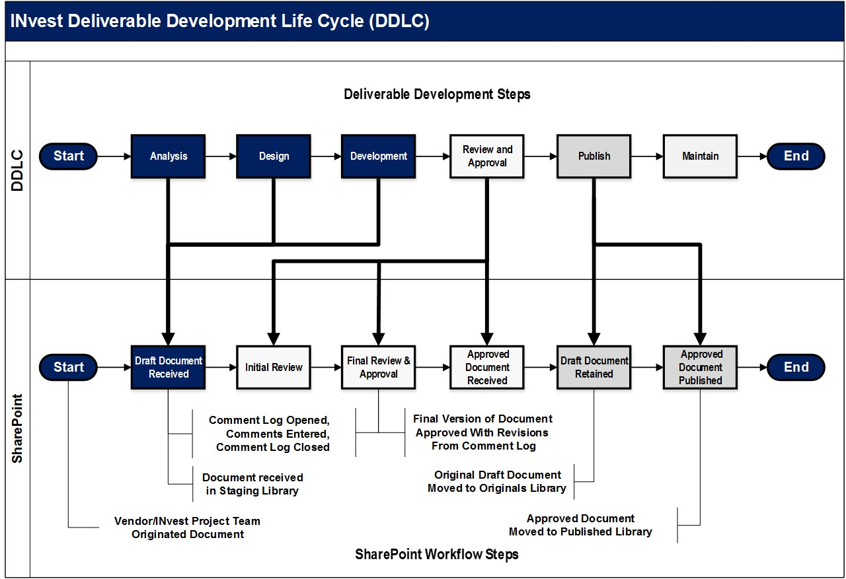

Figure 1: INvest Document DDLC Process

SharePoint Online Workflows
SharePoint review and approval workflows will be used whenever possible to manage a document through its life cycle. Workflows help ensure the location of each document in its life cycle is known at any given moment. Workflows also ensure all steps needed to review and approve a document are completed and that all reviews, approvals, and sign-offs are accurately recorded.

INvest Project document reviews and approvals will be completed by multiple persons, with no specific sequence or order of completion required. Comment logs and meetings will be used for most documents to determine the revisions to be made to the initial draft document.

In order to meet the INvest Project document DRAP review and approval process, the workflows configured must allow for:
- Multiple reviewers and approvers
- The use of Comment Logs
- Parallel reviews and approvals
- Initial draft review and final draft review and approval
As much as possible, the standard, “out of the box” SharePoint workflows will be utilized, but some customization of the workflows will be necessary in order to facilitate document processing. Any customization done will be based on business requirements developed by the project team while working within established CSB SharePoint Governance.

Table 7 lists the recommended INvest Project document management process SharePoint workflows.

Table 6: INvest SharePoint Document Workflows
Workflow | Task/Description
Initial Draft Document Review | - Task created to review initial draft document and enter comments in Comment Log.  - Sent to all document reviewers.
Final Document Review and Approval | - Task to review and approve final draft document that incorporates all agreed to revisions from Comment Log  - Sent to subset document approvers.
Abbreviated Document Revision | - Task to review and approve minor document revision  - Sent to single or a limited number of reviewer/approves; used to make changes to document formatting, correct errors, or to make minor revisions with no or minimal impact to document content.

Document Metadata
In order to identify, organize, and track INvest Project documents, the SharePoint Document Properties metadata feature will be used. The use of document metadata to manage documents has several benefits including, but not limited to:
- Providing enhanced document tracking and status reporting
- Simplifying the document management process
- Eliminating manual entry of information thereby decreasing the chance of error
- Ensuring consistency across the INvest document environment
- Providing key criteria for the enhanced SharePoint Online search capability

It will likely prove to be that the metadata for different libraries or specific document types may differ; to address this possibility different Document Properties can be configured and displayed in a specific library as required.

Table 8 includes a list of typical INvest metadata, including SharePoint default, recommended, and suggested metadata.

Table 7: INvest Document Metadata
Metadata | Status | Value/Description
Name | Default metadata | File/document name (must align with CSB SharePoint naming convention).
Title | Default metadata | Does not need to match Name or meet naming convention but special characters should not be used.
Version Number | Default metadata | Generated by system, configurable in Version History.
Created Date & Time | Default metadata | Auto generated by system.  Indicates person that created the document.
Created by | Default metadata
Modified Date & Time | Default metadata | Useful for tracking document revisions.
Modified by | Default metadata | Useful for tracking document revisions.
Document ID | Default metadata | Auto generated by system for each document.
Deliverable Expectation Document | Recommended | Yes/No to indicate the document requires an approved DED.
Document Originator | Recommended | Vendor or CSB Project Team originating the document, used for tracking and reports.
Document Type | Recommended | Needed to logically organize documents and for document tracking and reports.
Document Version | Recommended | Indicates Initial Draft or Final version, required for document review and approval in INvest Document Management process.
Status | Recommended | Needed to track documents and for generating document status reports.
Comments | Suggested | If included in Document Version History gives a quick view of revisions made to a document.
Priority | Suggested | An alpha (High, Medium, Low) or numeric value (1, 2, 3) used to assign a relative importance to a document in the review and approval process. Used with the document status for tracking and generating reports.
Tag | Suggested | Helpful in logically organizing documents and to identify similar documents.
Required Approver | Suggested | Used to identify specific approvers for certain document types (plans, security documents, etc.)

Document Statuses
Critical document properties (metadata) will be used to track documents throughout the review and approval process. Using metadata, metrics, dashboards, reports, and audits will be provided at regular intervals or as needed. Table 9 includes suggested document statuses that will allow documents to be searched by status and displayed in Document Properties.

Table 8: Suggested Document Statuses
Status | Description
Received | - Document moved to INvest Staging Library by PMO and received by librarian.
In Initial Review | - Document in Initial Review workflow.
In Final Review | - Document in Final Review workflow.
Reviewed | - Document Reviews completed.
In Approval | - Document in Approval workflow.
Published | - Document Approval complete – document published.
On Hold | - Document review and approval temporarily paused/halted.
Rejected | - Document has been rejected and returned to vendor/Project Team.

INvest Artifact Lifecycle
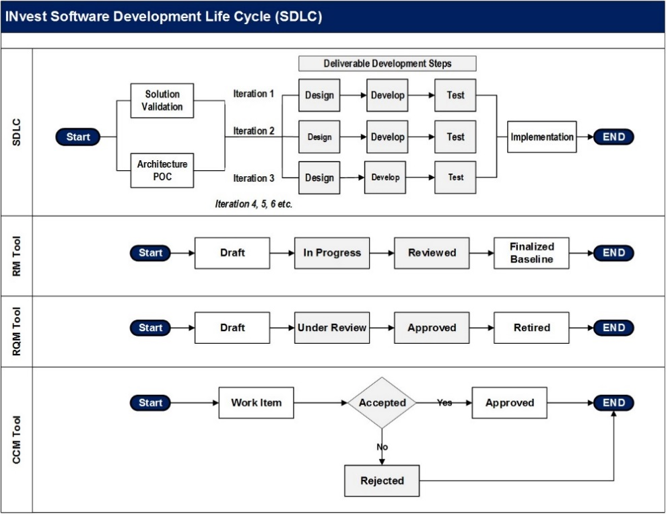
Vendors or CSB teams creating artifacts follow a basic iterative SDLC process. Once the DDI vendor on-boards, CSB’s agile process will be refined and depicted in the INvest Governance Manual. All steps will be completed within the ALM tool. Once an INvest artifact is ready for approval, it will be baselined and proceed through the review process. Artifacts will be reviewed and approved using ALM workflows. To efficiently manage artifacts in the tool, it will be necessary to configure metadata for tracking documents, creating modified views to facilitate information display, and workflow tasks to complete document reviews and approvals. Figure 2 depicts the SDLC process and how it works in conjunction with the DRAP.

Figure 2: INvest SDLC Process

Document Management Process Metrics and Reports
An important component of the Document Management Strategy will be to provide project metrics and information to generate reports. Key metrics will include document/artifact inventories, the amount of document storage space used and projected as needed, document/artifact statutes in the document management process, and audit findings and recommendations. The INvest PMO will be responsible for and manage project metrics and reports with the assistance of the Librarian.

Records Management
Records management includes the creation, maintenance, use, and disposal of records. The goal of a document management strategy is to develop a process for the managing of records in a consistent and efficient method. This management process includes a scheme for the archiving and/or deletion of documents and artifacts.

Archived materials are documents that record information about past activities and act as memory aids to enable users to recall the information about those past events at some time in the future. Archiving documents from the tools may enhance access to other needed documents. INvest Project documents can be archived as needed during the project using the existing CSB SharePoint Online archival process. ALM also has an archival process that can be utilized.

If, at any time during or at the end of the INvest Project, it is determined necessary to remove INvest Project documents and/or artifacts, an appropriate process aligning project requirements for purging, removal, or archiving will be developed.

Implementation
The Document Management Strategy for the INvest Project will commence once the DDI vendor is selected and the required resources have been hired and trained. The INvest PMO will be responsible for planning and conducting the implementation of the Document Management Strategy.
PMO planning will determine the type of training and communication needed throughout the INvest Project as it pertains to the Document Management Strategy. The INvest Project Librarian will be the key resource for identifying document management training and communications needed throughout the project. Any issues regarding the document management processes will be escalated to the INvest PMO Manager and a decision will be made to resolve the issue.

Related Documents

Table 9: Related Documents
Document | Document Description
CSB SharePoint Online Governance | Includes CSB SharePoint Online guidelines and best practices including the file naming convention.
INvest Governance Manual | Includes all project management and SDLC processes that will be utilized for the INvest Project.
INvest Glossary | Includes all INvest acronyms and terms.

Document Revision History

Table 10: Document Revision History
Version | Date | Prepared/Revised By | Revisions
v0.1 | 12/20/17 | Dawn McNeal, Karli Rice, John Rupp | Document draft ready for INvest WG and SPOT review.
v0.2 | 01/08/2018 | Linda Waller | Revision based on comments. Reformat to comply with Style Guide. Add Table of Tables and Figures.
v0.3 | 01/23/2018 | Linda Waller | Incorporated approved changes from Rama Ambarte.
v1.0 | 01/29/2018 | Linda Waller | Published approved document.
V1.1 | 06/10/2019 | Dawn McNeal | Revisions due to RFS updates.

Attachment A – INvest Project Deliverables: Documents/Artifacts

Table 11: INvest Project Deliverables: Documents/Artifacts
(Add once finalized)

